TRACK & FIELD
ATHLETICS

COVID-19 SPORTS RECOVERY PROTOCOLS
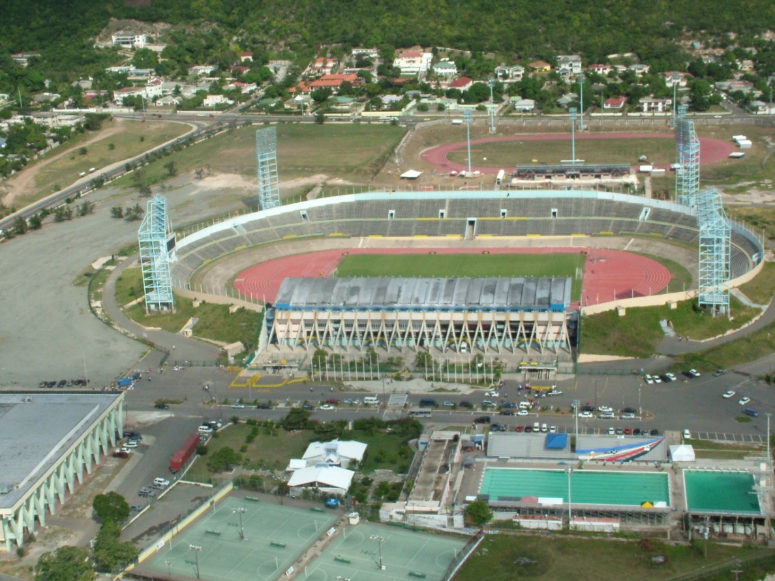
GUIDE DOCUMENT
TABLE OF CONTENTS

GUIDELINES FOR COMPLETING TEMPLATES 1
APPLICATION PROCESS 3
EVENT ORGANISER/ SPORT ASSOCIATION LETTER TO OFFICE OF DISASTER PREPAREDNESS AND EMERGENCY MANAGEMENT 5
SPORT RECOVERY ACTION PLAN TEMPLATE 8
EVENT ORGANIZER’S DETAIL 9
Section A: Purpose 10
Section B: Introduction 10
Section C: Background to the development of the proposal 10
Section D: Governance & Monitoring of the Protocols 11
Section E: Returning to Training & Competition 12
Section F: Communications & Records Management 15
Section G: Facilities Management 16
Section H: Concessionaires/ Tuck shops/ Bar/ Canteens 17
Section I: Management of Illness 17
Section J: Permits and approvals 18
FOREIGN BASED COMPETITORS 19
Section K: Accommodations 20
Section L: Transportation 21
Section M: Testing 21
Section N: Travel requirements 22
EVENT PARTNERS’ CONFIRMATION OF RECEIPT OF PROTOCOLS 23
SANITATION INSPECTION CHECKLIST 24
TRAINING ATTENDANCE REGISTER 27

GUIDELINES FOR COMPLETING TEMPLATES
In general, individuals are required to practice social distancing therefore it is generally not recommended that we participate in organized activities and play sports such as basketball, baseball, and football that are held on play fields, open areas, and courts.
These activities and sports typically require coaches and athletes who are not from the same household or living unit to be in close proximity which increases their potential for exposure to COVID-19.
However, since February 2021, sport has been included in the Disaster Risk Management Enforcement Orders. This integration of sport means that training and competitions can be delivered in a safe environment with appropriate measures that will reduce the transmission of the COVID 19 virus.
The following factors should be taken into consideration when completing the template:
- physical and social distancing
- number of persons involved (as teams)
- capacity to clean and disinfect the equipment used in the sporting event and
- whether the setting is indoors or outdoors
- If settings can be controlled
- If separate entry and exit points can be controlled

The template is divided into the following sections
Section A: Purpose
Section B: Introduction
Section C: Background to Development of Protocols
Section D: Governance & Monitoring of Protocols
Section E: Returning to training and competition
Section F: Communications and Records Management
Section G: Facilities Management
Section H: Tuck Shops/ Bars/ Canteens
Section I: Management of Illness
Section J: Permits & Approvals
Section K: Accommodations
Section L: Transport
Section M: Testing
Section N: Travel requirements
Kindly note that most statements are written in positive language to make it more reader friendly.

Read each section carefully before responding (ticking or writing Yes or No options).

APPLICATION PROCESS

STEP 1: To decrease the risk of exposure to COVID 19 the attached JAAA Manual for Track & Field Teams During Covid-19 must be used to guide the development of Meet Organizers proposal to convene track and field meetings. The document must include standard practices such as the ability to clean and sanitise gears and equipment, to practice social and physical distancing, to control number of persons present and to control the entry settings and spaces where training and competitions may be held.
Proposals must be accompanied by a letter from the governing Sports Body to the Director General of Office of Disaster Preparedness and Emergency Management summarizing the contents of the Sports Recovery Proposal.

STEP 2: Event organisers wishing to host events, must develop their Sports Recovery Proposals at least six (6) weeks before proposed date of event. Event organisers should send their proposals to the Jamaica Athletics Administrative Association (JAAA), governing body for review and endorsement, accompanied by a letter from the organizer to the Director General of the Office of Disaster Preparedness and Emergency Management summarizing the contents of the proposal.

STEP 3: The JAAA will review and provide a letter of support or endorsement for the event, the event organiser’s letter to ODPEM and the event organiser’s sports Recovery Proposal to the Principal Director of the Sports Policy Development and Monitoring Branch at Ministry of Culture Gender Entertainment and Sport for review. Emails should be sent to sportdivision@mcges.gov.jm

STEP 4: The Ministry of Culture Gender Entertainment and Sport will send (1) the proposal, (2) the JAAA endorsement letter, (3) the event organiser’s letter requesting approval and (4) the event organiser’s sports recovery proposal to the Office of Disaster Preparedness and Emergency Management and the Ministry of Health and Wellness for review and final approval.

STEP 5: The Office of Disaster Preparedness and Emergency Management and the Ministry of Health and Wellness should be invited in writing by the event organizer to conduct a site inspection.
A walk through/ site inspection without the Ministry of Health and Wellness is not considered a walk through/site inspection.

STEP 6: Upon site inspection the Ministry of Health and Wellness will issue a letter of ‘NO OBJECTION’ or upon assessment of the facility or venue will make recommendations to the organisers for approval to be granted. A second site inspection visit may be necessary.

STEP 7: The Office of Disaster Preparedness and Emergency Management will issue its approval.

STEP 8: On receipt of ODPEM’s approval, event organisers must make the following applications:
- Local Parish Council
- Local Medical Health Officer
- Local Police Department
- Local Fire Department

STEP 9: With all approvals and permits granted the event organizer may EXECUTE!

Kindly note that all approval and permit issuing entities along with officers from the Institute of Sports will audit and assess the implementation during the event to ensure that the event organisers are compliant with the standards presented and approved in their Sports Recovery Proposals

EVENT ORGANISER/ SPORT ASSOCIATION LETTER TO OFFICE OF DISASTER PREPAREDNESS AND EMERGENCY MANAGEMENT

Organisation Letterhead or Return Address

DATE

Mr. Richard Thompson
Deputy Director General
Office of Disaster Preparedness and Emergency Management
2-4 Haining Road
Kingston 5

Dear Mr. Thompson,

Re: Request for approval for (Name of organization) to host (Training/ event)
The (Name of organization) hereby writes to you on instruction from the Ministry of Culture Gender Entertainment & Sport (MCGES) regarding the process of obtaining approval for the (Name of organization/ organizer) to (activity to be executed).
We are requesting that approval be given to host (Name of event) at the (Location) on the (Date/s). The event is scheduled to start at (Time) and a maximum of (# of people who will be in attendance). A table may be included to provide additional breakdown
We are requesting that approval be granted under the following conditions which have also been included in the attached (Sport organization) Jamaica Sports Recovery Proposal.
- The Medical Officer of the Local Health Department assesses and determines the venue suitability and capacity
- The Municipality must issue the necessary permits for events
- Venues for training will be enclosed
- The testing, monitoring and risk management plan must be endorsed by the Ministry of Health and Wellness
- The testing plan must be done primarily by the local Health Department in which the players reside
- All players, coaches and support staff must be tested prior to the resumption of training at the University Hospital of the West Indies
- Separate entrance and exist will be identified at the venues
- Masks covering the nose and mouth must be worn at all times except when playing
- Supporting personnel and COVID 19 Marshalls may wear a face shield in additional to a mask covering the nose and mouth
- A COVID 19 Compliance Team must be established
- The (Name of the Association) will provide copies of records, registers, schedules, rosters related to data management upon request
- Personal items such a gear, towels, water bottles must not be shared
- Safety posters, signs and physical markers must be installed to ensure consistency in messaging
- Protocol reminders must be done every twenty (20) minutes to remind attendees of the protocols that are in place
- Physical marking at training facilities in the locker/ dressing room according to Government of Jamaica issued Orders
- Adhering to capacity limitations in spaces at all times
- Sanitization/ handwashing stations will be installed
- All participants’ must have their temperature checked, recorded and then sanitize in order to enter the compound/ training facility
- (List equipment items and gears) must be sanitized before, during breaks and after training must be sanitized during breaks
- Sanitization teams must be established to ensure that all bathrooms are sanitized every 30 minutes
- High traffic areas will be sanitized every 30 minutes by the Equipment and Facilities Manager
- No physical contact will be allowed except that which is acceptable during play
- A maximum of (# of athletes/ players) will be allowed to access changing rooms at any one time. Access to changing room must be monitored by the COVID 19 Compliance team
- There must be no consumption of food during training sessions
- Water and other forms of hydration must be supplied by Team Managers in sealed bottles or from personal marked water bottles.
- Participants/ attendees must leave the venue as soon as training is finished. No loitering will be allowed
- All protocols set out in the Disaster Risk Management Act and included in the protocols set out by the (Name of organization)
- Approved protocols must be shared with all participants
We remain available to provide any further clarification necessary.

_________________________
Name of Executive Officer
Position

Copy: Mr. Garth Gayle, President, JAAA
Mr. Ian Forbes, First Vice-President, JAAA
Mrs. Suzette Ison, Snr. Dir. Sports Development & Monitoring, MCGES

SPORT RECOVERY ACTION PLAN TEMPLATE

EVENT ORGANIZER’S DETAIL

Name of Association:

Name of Sporting Discipline:

Name of President:
Telephone

Email Address:

Name of Executive Member 1:
Post Currently Occupied:
Telephone
Email Address:
Number of clubs/ groups
registered with association:

Number of Coaches
with Association:

Section A: Purpose
This section allows you to seek permission to host training or events. This will include your organisation doing the following:

- Identifying local and international competitions or camps for which your team/s need to engage in training or prepare for competition

- Select the type of event your organisation is requesting approval for:
- Training
- National Championships
- National Qualifiers
- Workshop
- Local Competition
- International Competition
- Schedule of events including the date/s, venue/s, time slots, the total number of persons who will be present including athletes and coaches. *A table like the one below may be used.

Date | Name of event | Time slots | Venue | Maximum number of persons
- Please add rows if necessary

Section B: Introduction
This section allows your organisation to summarise the contents of the Sports Recovery Proposal by briefly mentioning some of the strategies the organisation has undertaken to ensure the safety of the stakeholders involved in the sport. For example, coaches would have been advised to host staggered training with no more than fifteen people.

Section C: Background to the development of the proposal
This section allows you to describe the resources used to develop this proposal. The following may be shared in this section:

- The persons and entities which contributed to the development of the proposal
- Description of the kind of help the organisation has received from institutional governing bodies.
- International resources used to guide the development of the proposal
Name of Organisation (clubs/ other stakeholder) | Identified Participant in the Process

*Please add rows if necessary

Section D: Governance & Monitoring of the Protocols
- Explain how your organisation will go about educating and training staff and volunteers on maintaining a COVID-19 free environment and how visible your COVID 19 will be.
Statement | YES | NO | Comments
Sensitizations sessions have been held on general protocols for training and competitions
Sensitizations sessions will be held for specific events to be held
Training for COVID 19 Marshalls, staff and volunteers will be delivered through the Ministry of Health and Wellness
COVID 19 Marshalls will be clearly identified with labelled or mark apparel
Persons breaching protocols will be asked to leave
ALL participants to be engaged in local competition will be tested (this includes but is not limited to athletes, coaches and officials who will be present for the activity)

*Please add rows to include information not present in the table

- This section allows your organisation to speak to the monitoring and compliance of the protocols. It allows you to state if a COVID-19 Compliance Team has been established and to identify the COVID 19 Compliance Marshalls, staff and volunteers.

Name of COVID-19 Compliance Marshall/ staff/ volunteer | Contact information

*Please add rows to include more persons
The COVID 19 Compliance Officers’ responsibilities are as follows:

Section E: Returning to Training & Competition
- Using the table below please indicate Yes or No for the standard activities that will be implemented for normal training and competition. Please add rows to include unique features of your sporting discipline:

Statement/ Question | Yes | No | Comments/ Not applicable
Temperature checks will be conducted on ALL participants entering the facility
All participants will be sanitized upon entry to facility/ venue
A maximum of fifteen persons including the coach and athletes will be present
Spectators will be allowed
Persons who test positive for COVID 19 or are waiting for test results will be allowed to train until they receive their negative result
The names of all participants access the facility will be documented (this will include athletes, coaches, volunteers, ancillary staff and any other persons accessing he facility)
Athletes will arrive at training dressed and ready to play to limit the use of changing rooms
Athletes using public transportation will shower before interacting with team members or coming in area of play
All persons will wear masks at all times except when involved in play or physical activity
Sanitizations will be installed at strategic points during training
Hand washing stations will be installed at strategic points during training
Before each training session protocol reminder sessions will be conducted
Sharing of gears, equipment, towels, water bottles and other personal items will be prohibited
Gears and equipment will be sanitised before during and after training
Shared gears will be increased to allow for rotation in sanitization process
Sanitization schedules will be documented and shared upon request
Any individual reporting illness will be immediately removed from the area of practice to an isolation area
Any individual reporting illness will be safely transported from the facility in private transportation and medical assistance will be sought
Protocols will be shared with all stakeholders, including coaches, athletes and parents
Uniforms/ kits will be laundered by one specific person
Uniforms/ kits will be laundered by athletes
Trainees will leave facility within thirty (30) minutes subsequent to end of activity/ event
Food consumption will be allowed
*Please add rows to include information not present in the table

Section F: Communications & Records Management
Using the table below, select the options which best describe the processes that will be conducted to support effective and efficient communication of these protocols. Also select the options which show effective documentation.
Statement | YES | NO | Comments / Not applicable
Protocols will be shared with all participants, including athletes, coaches, officials, staff, parents and volunteers
Protocol reminders will be done every twenty (20) minutes to remind attendees of the protocols that are in place

Sanitization inspection schedules will be documented and submitted upon request
Attendance registers will be stored and submitted upon request

*Please add rows to include any information not present in the table

Section G: Facilities Management
This section speaks to the treatment of the facilities. It addresses capacity limitations, entry and exit points, sanitization and use of the space being used.
Statement/ Question | YES | NO | Comments/ NA
Adhering to capacity limitations in spaces at all times
Training facilities will be cleaned and sanitized before during and after training
The facility will have separate entry and exit points
Physical marking at training facility will be placed in strategic areas such as locker/ dress room according to Government of Jamaica Issued Orders
Safety Posters, signs and physical markers must be installed to ensure consistency in COVID 19 measures messaging
Training facility is secure and no unauthorized person can access the facility
Facility is outdoors and open air
Training facility will have separate entry and exit points
Use of bathrooms will be limited to 50% capacity and will be regulated by staff or volunteer
Use of showers, locker or changing rooms will be restricted. Where this cannot be maintained use of showers will be limited to 50% capacity
Bathrooms will be sanitized at least every hour
High touch areas such as door knobs, seating areas and counter tops will be sanitized every thirty (30) minutes
*Please add rows to include any information not present in the table

Section H: Concessionaires/ Tuck shops/ Bar/ Canteens
Statement/ Question | YES | NO | Comments/ NA
Food will be consumed
The staff in prep areas will be spaced at physical distancing of 6ft
Cashiers will be separated from customers with a screen
Food providers will be certified by the Ministry of Health Public Health Department
Food dining will be in a controlled area with minimum spacing of 6ft
Food customers will be in a que of 3ft and 6ft

*Please add rows to include any information not present in the table

Section I: Management of Illness
Statement/ Question | YES | NO | Comments/ NA
Participants and attendees exhibiting signs of illness will be escorted to isolation area
Isolation areas will be equipped with medical team such as Personal Protective Equipment such as masks and gowns
Individual should be safely transported from the compound/ facility
Medical assistance should be sought for persons exhibiting symptoms
Where possible at training sessions private transportation should be arranged
For competitions ambulance services will be used
The local public health department will be notified about suspected and confirmed cases
Persons who have tested positive will self-isolate for 14 days
*Please add rows to include any information not present in the table

Section J: Permits and approvals
Statement | YES | NO | Comments/ Not applicable
The Medical Officer of the Local Public Health Department will be invited to assess and determine the suitability of the venues
Local Municipality permits will be applied for upon receipt of approval
Local Jamaica Fire Brigade permits will be applied for upon receipt of approval
Local Jamaica Constabulary Force permits will be applied for upon receipt of approval
All applications for local and national competitions will be accompanied by the MHW Risk Assessment Ranking tool

FOREIGN BASED COMPETITORS
Section K-N:
These sections speak directly to conditions where teams are travelling to Jamaica for competition or when international teams are visiting Jamaica for competition.

Section K: Accommodations

Country of Competition: JAMAICA

Name and location of Accommodation___________________________________
Statement | YES | NO | Comments/ Not applicable
Occupancy will be restricted to one person per room
Housekeeping staff will be also participate in bio secure bubble
All participants, including players, officials, coaches administrators will receive their meals in their rooms
Visitors will be allowed at the hotel
Only event participants will have access to hotel gym
Accommodations will be approved by host country’s ministry with responsibility for public health

*Please add rows to include any information not present in the table

Section L: Transportation
Statement | YES | NO | Comments/ Not applicable
Private contractors will be contracted to provide transportation
Drivers will be included in the bio secure bubble
Only players/ athletes will travel in event vehicle
Please add rows to include any information not present in the table

Section M: Testing
Statement | YES | NO | Comments/ Not applicable
All participants will be PCR tested at least 72 hours before arriving in Jamaica
All participants will be PCR tested
Please add rows to include any information not present in the table

Section N: Travel requirements
Statement | YES | NO | Comments/ Not applicable
The organisers/ managers will ensure that participant will have passports
The organisers/ managers will ensure that participants have procured visas
The organisers/ managers will ensure that host country’s COVID 19 measures will not be breached

EVENT PARTNERS’ CONFIRMATION OF RECEIPT OF PROTOCOLS

For each recipient of the Sport Recovery Association proposal, please have them complete and sign this page as evidence of their receipt of and compliance with the proposal.

I _____________________ of the ______________________have received the Sport
(RECIPIENT/ ORGANISATION)
(NAME OF PERSON)

Recovery Plan Proposal for ________________________ on _____________________
(DATE)
(NAME OF SPORTING DISCIPLINE)

I commit to comply with the protocols and any additional resources that will ensure the health and safety of all adults and children involved in sports.

SIGNATURE: _________________________

Date: ___________________________

SANITATION INSPECTION CHECKLIST
Name/ Location of facility:

Name of sanitation manager:

Week starting:

Cleaning agents used:

*Where the area or activity is not relevant please write N/A for Not applicable

CLEANING SCHEDULE

Areas/ Activity | Mon | Tues | Wed | Thu | Fri | Sat | Sun | Manager’s Signature
Example | 9:00 a.m. JD  12:00 noon  JD  5:00 p.m.  JD | Time & initial | Time & initial | Time & initial | Time & initial | Time & initial | Time & initial | Sign
Clean & disinfect all sanitizing stations
Clean & disinfect counter tops such as food contact surfaces or ticket service areas
Clean & disinfect door knobs
Clean & disinfect locker/ cabinet handles
Clean & disinfect light switches
Clean and disinfect seating areas
Clean & disinfect tables and chairs
Clean & Disinfect showers
Clean & disinfect decks
Refill soap dispensers
Clean & disinfect toilets
Clean & disinfect face basin or wash up area counters
Clean & disinfect wash basin and shower fixtures
Clean & disinfect exercise mats
Empty, wash and disinfect Garbage bins
Clean and disinfect onsite coolers
Clean & disinfect railings and fences
Clean & disinfect registers
Clean & disinfect computers, monitor, mice, CPUs, printers, keyboards
Clean & disinfect equipment
Clean & disinfect drawers and storage cabinets

TRAINING ATTENDANCE REGISTER

Name of Club/ group:

Name of Coach/ coaches:
Location of training session:
Date of training session:
Duration of training session:
Total Number of Trainees attending today’s session:

Total Number of Spectators attending today’s session:

Was the training facility sanitized before training started? Y/N

How many times throughout the course of the
training exercise were surfaces periodically disinfected?

NO | Full name | Arrival time | Temperature | Spectator/ Trainee S/T | Phone # | Email address | If going to school (Name of institution) | In the previous 14 days: Have you:  Experienced any COVID-19 symptoms? Fever/ cough/ sore throat/ difficulty breathing/ headache/ chest pain/ vomiting/ diarrhea/ abdominal pain. | In the previous 14 days have you been in contact with any suspected/ confirmed COVID 19 case/s? | In the previous 14 days have you travelled outside of Jamaica? If yes please state destination. | Departure time

